Feedback
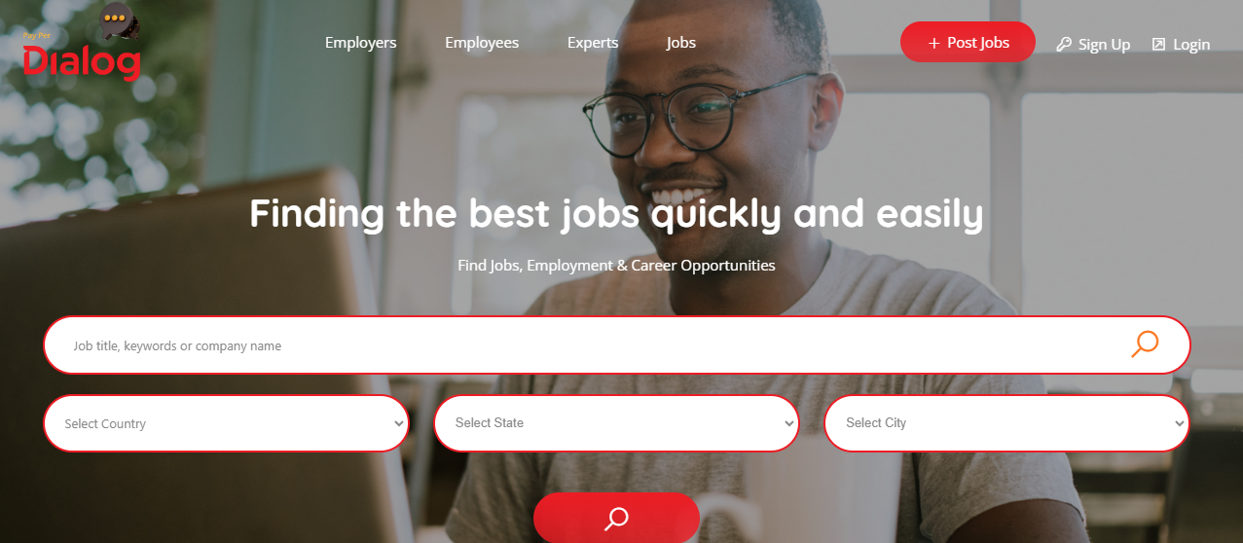

We can change the “employees” to “Job Seekers”
When I click the Employee – it shows me a list of employees. That is incorrect if I am a job seeker myself. It should take me to a portal where I have information about my resume, my skills etc, the jobs I applied to and the interviews scheduled for me.
When I click on Employers – it shows me a list of employers. It should ideally take me to an employer portal – with jobs I posted, candidates who applied, the money I spent etc.
--

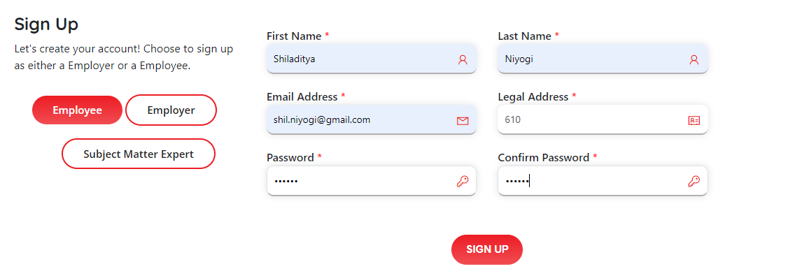
As I sign up, can we have some rules for the password (e.g. alphanumeric and special keys)
--
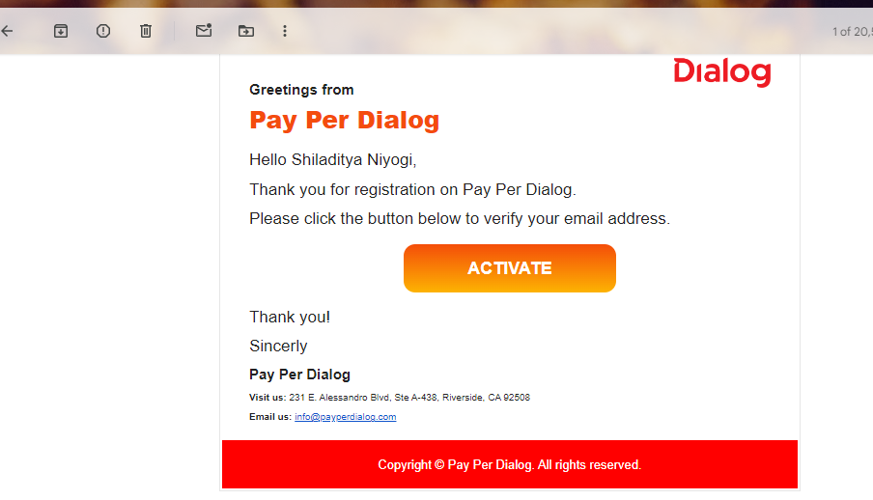
Looks good – may have to change the verbiage later
--
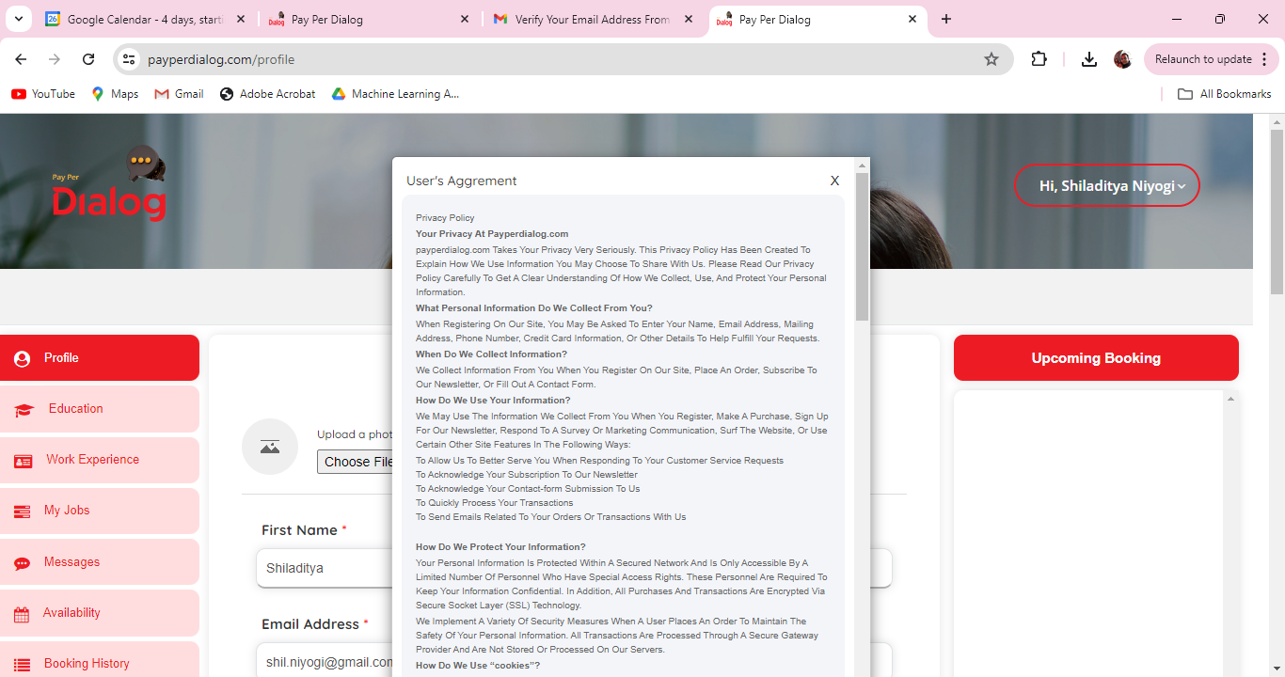
Will have to change the User’s agreement verbiage
This User’s agreement is coming back again and again even after I check and say Next. I had to close it by clicking on the x button.

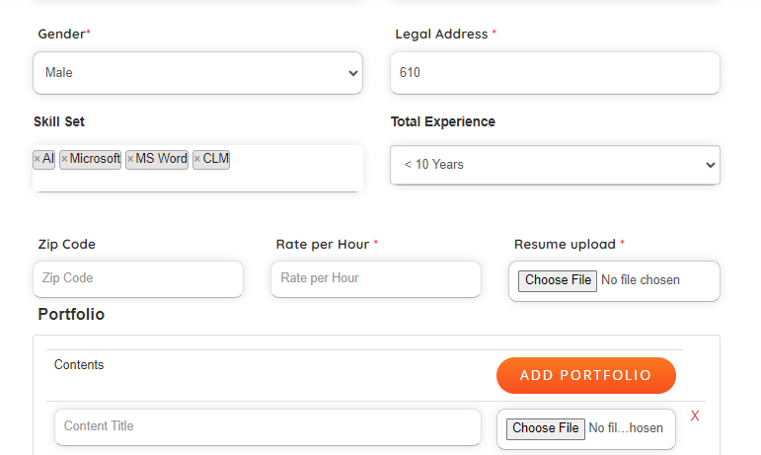
Total Experience “> 10 Years” should be an option

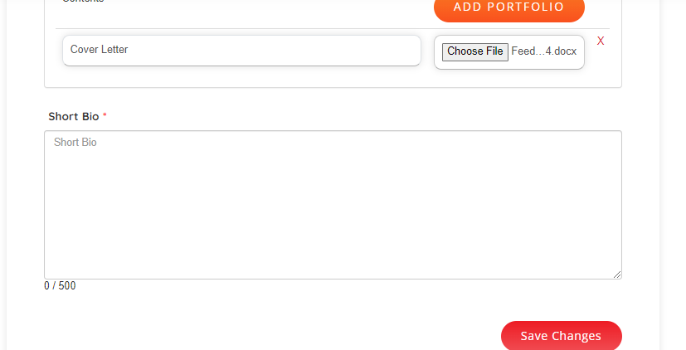
Instead of “Short Bio”, we can say “Please let us know what differentiates you as a candidate”
After Saving the User’s agreement again comes up.
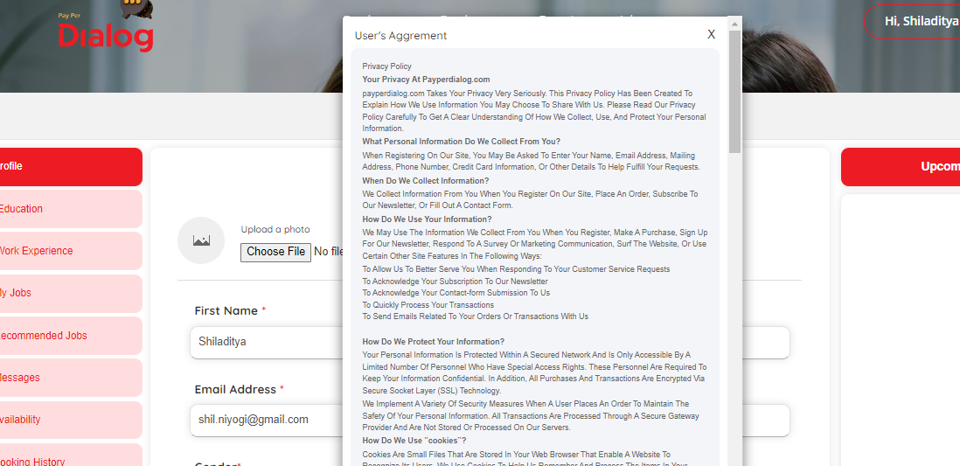
Also, there is a type in the heading – it should be “Agreement”.
BTW, the dialog box for User agreement is not dockable. Cannot see the save button till I zoom out significantly.
Also, it does not let me go to the other vertical menus as there is no “x” button anymore (or is there but invisible) - education, work experience, My jobs, etc.
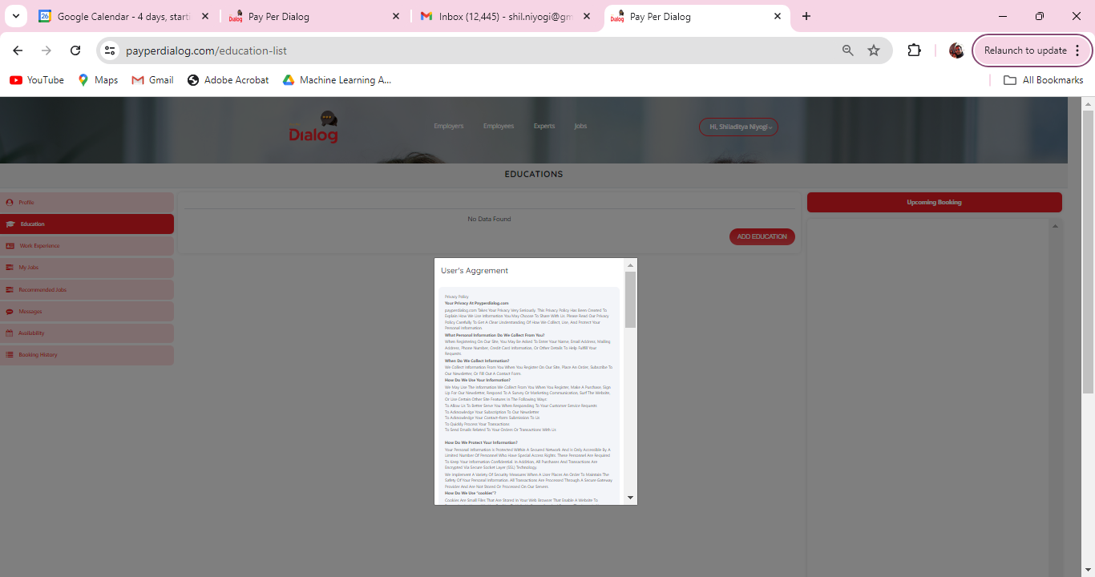

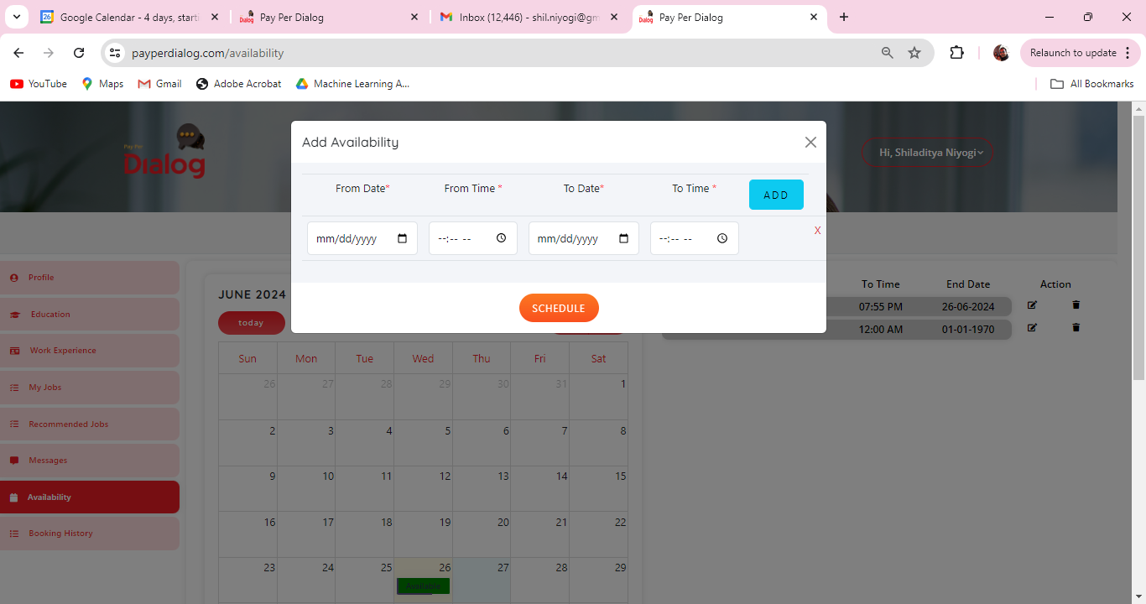
Here in the calendar, we can say “Show availability” and not “Schedule”

For employer
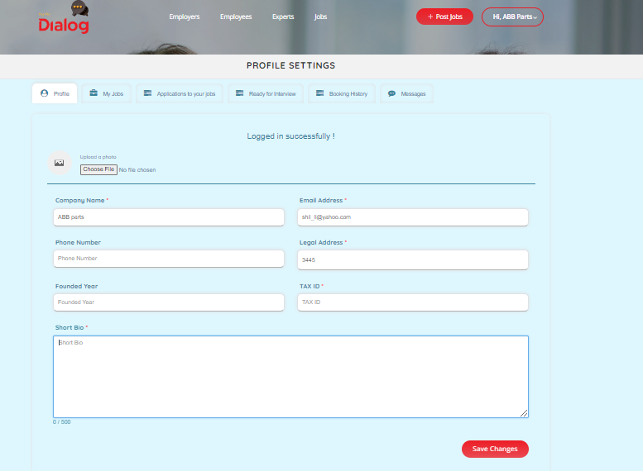
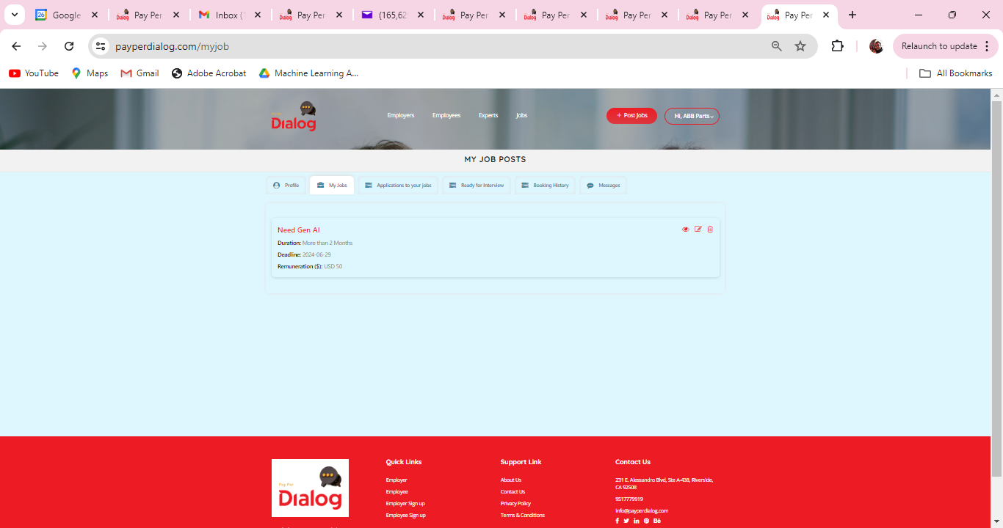

I applied to the job as an employee but I do not see the applicant as an employer. It should ideally show up as an applicant.
However, I show up in the ready for interview when I select “All Recommended employee” under the Skill Sets dropdown. How do we get to see this person for the job “Need AI..”? Is there a selection process before that?
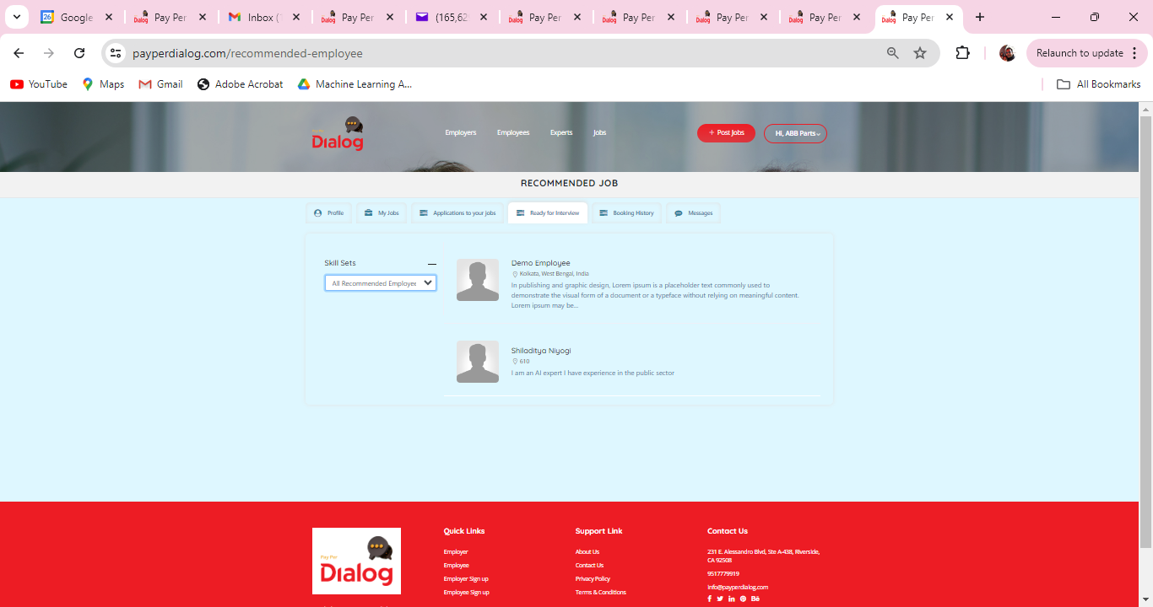

Also, when I select the employee I am not able to select the slot I do not see available slot.
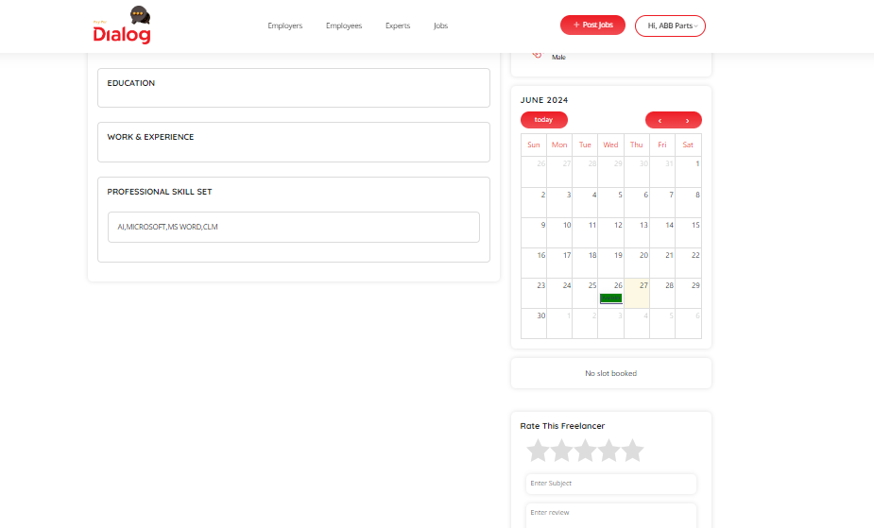

So I go back and login as an employee – and I face that User Agreement screen *which should come only when I am signing up”

I also see “pending” as an employee – what is that? Pending interview or rejection?
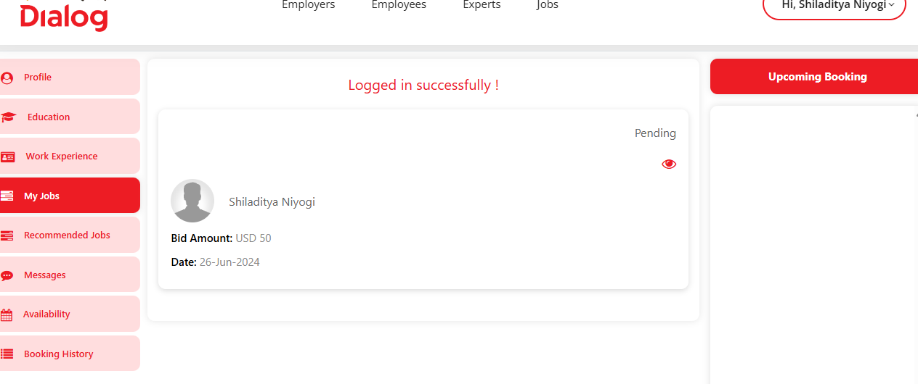

I add another slot
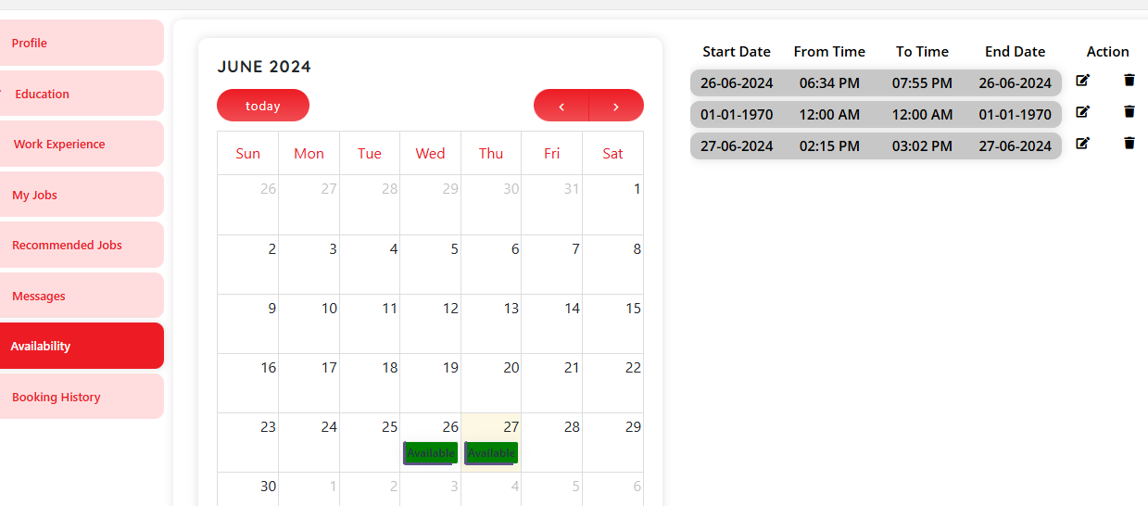

Now, as an employer, I cannot double click and get into employee’s availability

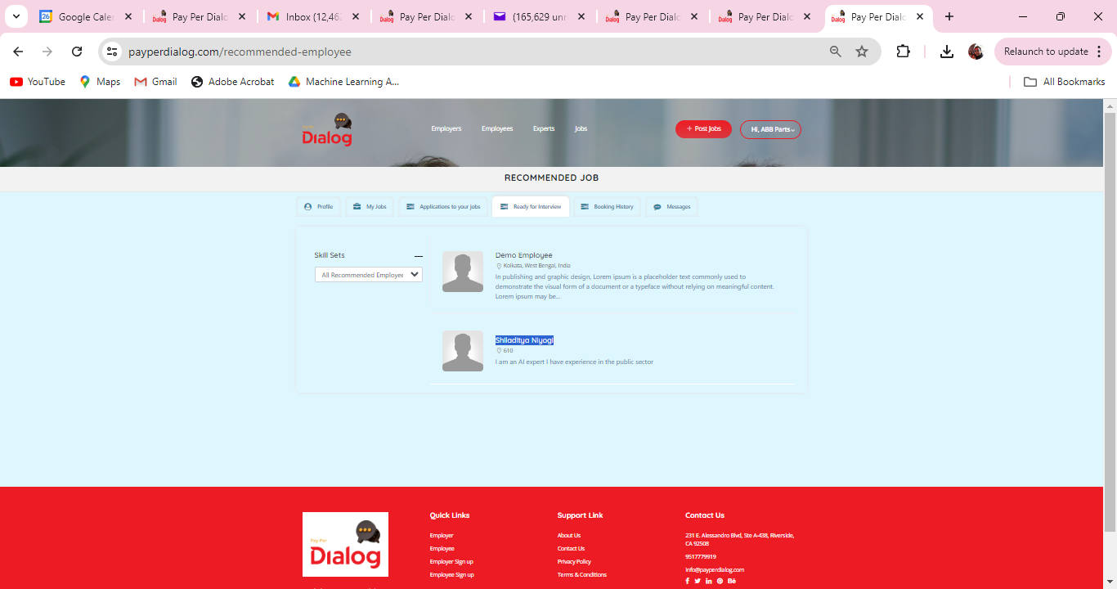

Only after I logged out from my other browser as an employee, it allows me to double click and select the employee.
As an employer I went ahead and booked the candidate
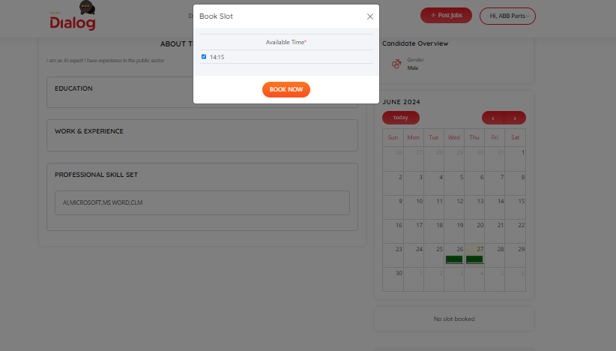

There should be an email sent or some notification. How do I start the interview as an employer or an employee?

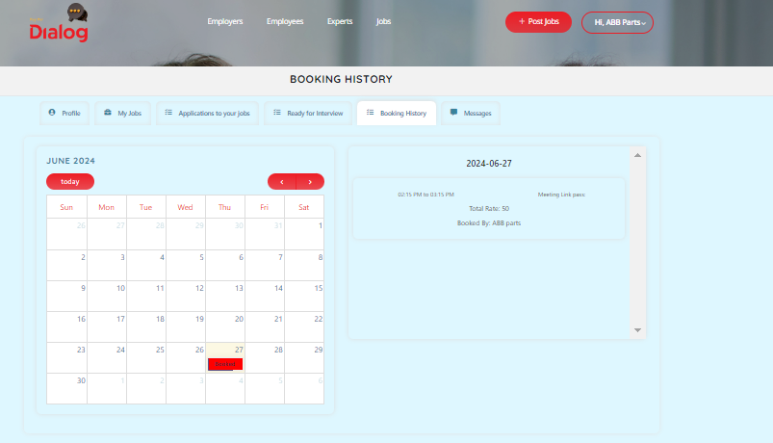
I don’t see a link for the interview for the employer.

When I click on the link of an employee I see this page:
